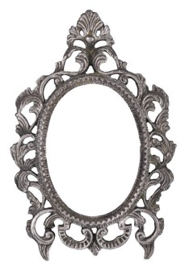
INSTRUCTIONS:
- We often have role models or people we admire. It could be their image, their energy, their people skills, leadership skills, the way they make life seem so easy and uncomplicated or something else.
- Whatever inspires you, this exercise helps you think about who you would like to be by considering what it is in others that you admire and aspire to: If you can see it in others, you already have that quality within you!
- Allow yourself 20 minutes of quiet time to relax and write your answers below!

1. Who are your Top 3 Role Models? Who impresses you? Who do you admire?
NOTE: They can be real or in your imagination, someone you know or don't, in a film or book, alive or even dead!
1. …………………………………… 2. …………………………………… 3. ……………………………………
2. Who has been most influential in your life over the last year, personally and in your career?
Personally …………………………………………… In your Career ………………………………………………
3. What about them has impacted you? What do you most admire about your role models above and why? What can you learn from them?

4. Which of these qualities would you like to emulate or have for yourself?

5. How could you begin to bring some of those qualities into your everyday life?
NOTE: Think how you could adapt what your role models do to fit you and your life, what unique slant could you add?
- …………………………………………………………………………………………………………………………………
- …………………………………………………………………………………………………………………………………
- …………………………………………………………………………………………………………………………………
- …………………………………………………………………………………………………………………………………
- …………………………………………………………………………………………………………………………………
6. Finally, what one specific action will you choose to move forwards with?
…………………………………………………………………………………………… by when ………………………………
Last word: Reading books, memoirs, autobiographies or watching/listening to podcasts, radio, films and documentaries about the people you admire can give you plenty of ideas and inspiration on how to grow.

