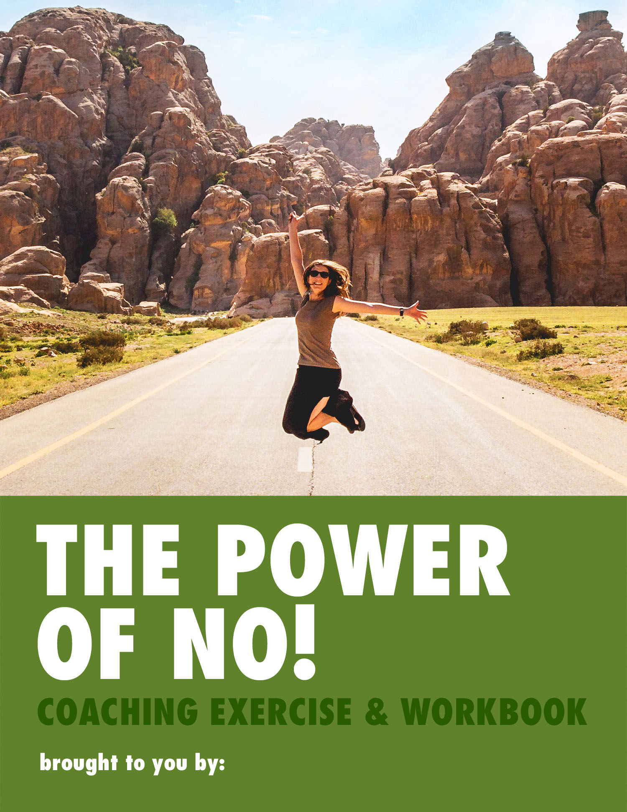
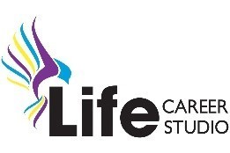
BACKGROUND:
- Most children go through a phase where their favourite word is "No". That's because no is a power word. It gives us a definite sense of self. This means saying "No" is an ideal opportunity to rediscover your priorities and sense of who you are.
- Until we learn to say "No" we continue to be overwhelmed with too much to do and not enough time. Have you noticed that it's usually important things impacted by not saying "No", like quality time with self or family, our health and our stress levels?
- Whether you learn to say "No" more often, or just learn to say "Yes" on your terms, it's time to release yourself from the burden of pleasing others. Give yourself time and freedom to be, and do, what matters to you. Let's get started!

When is it OK to say "No"?
1. What in your life do YOU need to say "No" to? Just write down whatever pops into your head below.
____________________________
____________________________
____________________________
____________________________
____________________________
……………………………………………………………

You ABSOLUTELY MUST Say "No":
- When you're stressed or overwhelmed
- When you're already doing too much
- When you're tired or sick

And REMEMBER

You always HAVE A RIGHT to Say "No":
- When it's someone else's issue
- When you feel taken for granted
- When it's something you don't want to do
- When there's something you'd MUCH rather do
- When it takes away from your values and wishes
- When you deserve or need some time to yourself

2. What currently stops me from saying "No" to these things? ___________________________

___________________________

3. My Beliefs about saying "No"
Simply answer the questions below with WHATEVER springs to mind. Don't worry if you make contradictory statements (this may even be part of the problem!), just capture anything and everything that comes up for you.

People who say "Yes" are: | People who DON'T say "Yes" are:
People who say "No" are: | People who DON'T say "No" are:
What I've noticed about myself from this exercise is _______________________________________
__________________________________________________________________________________

"There are only two words that will always lead you to success. Those words are yes and no. Undoubtedly, you’ve mastered saying yes. So start practicing saying no. Your goals depend on it!" Jack Canfield

4. Understanding The "Yes" Trap
"There is no pleasure in having nothing to do. The fun is in having lots to do and not doing it." Mary Little

- WHY do you say "Yes" when you'd rather be saying No?
- How do you BENEFIT by saying "Yes"?
- Understanding this is essential to saying "No" - and valuing your own goals, needs and time.
- When I say "Yes" I feel _____________________________________________________________
- When I say "Yes" I want other people to think I am ______________________________________
Examples: Maybe you want people to like you, think you're reliable, hard-working, helpful or to make yourself indispensable?

- By saying "Yes", what am I saying "No" to in my own life? _________________________________
Whenever we say "Yes" to something, we're saying "No" to something else - even if that something is simply relaxing!

- When I say "No" I feel _____________________________________________________________
- When I say "No" I worry other people will think I am _____________________________________
- If I said "No", I could say "Yes" to these things in my life __________________________________
What could you make room for that is truly important to you?
- Lastly, when I say "Yes", but I really want to say "No" I feel __________________________________
- My biggest fears about saying "No" are ________________________________________________
________________________________________________________________________________


5. The other "Know" - Know YOUR Priorities!

- How can we say "No" assertively when we don't know WHY we're saying "No"?
- In order to say "No" effectively you need to be in touch with what's important to YOU - to know YOUR priorities in life.
- Then it's much easier to say "No" because we're clear on what we want and need instead.

- What is MOST important to ME in life? _________________________________________________
- How would I like to spend MORE time? ________________________________________________
- Where would I like to spend LESS time? _______________________________________________
- What is my top priority this year? ___________________________________________________
- What is my top priority this month? _________________________________________________
- What is my top priority this week? ___________________________________________________
- If I had a magic wand I would _____________________________________________________
- My Top 3 Priorities in life right now are: 1. ____________________________________________
- ____________________________________________
- ____________________________________________
- How am I meeting my Top 3 Priorities in life right now? ___________________________________
SOME SAYING NO THOUGHTS:
- Managing the Guilt: As you learn to say "No" more, you'll probably feel more guilt! Assuming it's not genuine guilt that requires remedial action from you - CONGRATULATIONS! This guilt is a sign that you're making important, positive changes in your life.
- Evaluate EACH situation: As most things in life, there is no one size fits all answer. Everything depends on the relative importance of the situation, people affected, what's going on in your life at the time, the person asking, your history with them etc.
- Changing gradually is just fine: If, in the past you have been a "Yes" person, you may want to gradually become a person who says "No". Take your time and practice on small things, working up to larger "No"s.
- Soften the blow: If you do decide to go 'all out' with your "No"s remember that others may find this a bit of a shock. It may help (although it's by no means necessary!) to find your own way to soften it for them.
- Practicing: Try imagining you're someone who is already comfortable saying "No", and mentally rehearse difficult situations. You can also role-play with someone you trust.
- Feeling good: When "No" is the right answer for you, say it pleasantly, assertively and with conviction. If it leaves you feeling strong and good in yourself (even if there is some guilt) then you've made the right choice for you!


6. Preparing to Say "No"

In what SPECIFIC areas or situations in my life do I need to be saying "No" more?

1. _______________________ 2. _______________________ 3. _______________________

My NEW BELIEFS about Saying "No" are:

1. _______________________ 2. _______________________ 3. _______________________

The Saying "No" TECHNIQUES that I can see myself using are: (see Appendix for ideas)

1. _______________________ 2. _______________________ 3. _______________________


7. My "Saying No" Plan!

- If you want things to be different then you will need to do things differently - but you can't change everything at once.
- Using your answers to all the questions above - and anything else you already know about yourself - identify 3 actions to get you started. Be as specific as you can!

1st Action When _______________ asks _____________________ then I will ________________

2nd Action When _______________ asks _____________________ then I will ________________

3rd Action When _______________ asks _____________________ then I will ________________

Now copy these out on post-it notes and stick them in your car, wallet, locker, fridge door, desk drawer or any place where you will see them often.
"No is just a word - two small letters that set you free!" Emma-Louise Elsey

Appendix - Helpful Tips &Techniques for Saying "No"

Helpful Tips:

- Tell the truth: ALWAYS find a way to be truthful. There's nothing worse than being caught in a lie. But you can leave out information (like that you could reschedule an appointment so you are available) to protect your "No"…

- Timing can be everything: No does not mean "No forever". Sometimes you just need time or circumstances to be right. So don't allow yourself to be pressured into giving a response if you're not ready. Sometimes you just need time to figure out if it's really a "No", a "Not now" or a "Never".

- Stay firm: People who are used to relying on you saying yes will try to persuade you. Don't get drawn into discussion. Just repeat your No and have phrases ready. "I'm unavailable", "I can't right now" or "I have other commitments".

Helpful Techniques:

SIMPLE
- A simple "No, but thanks for asking/thinking of me."

SOMETHING ELSE
- A simple "I’m already doing ________ / have a dentist appointment"

Buy Yourself Time – when unsure how you feel or need time to prepare a response
- "I'm away from my desk right now, can I let you know once I have my diary in front of me?"
- "I'm just in the middle of something/a tight deadline. Can I get back to you tomorrow/next week?"

Deferral - good for other people's problems and issues
- "I'm crazy busy this week/month. Can it wait until next week/month?"

TRANSFER - good for maintaining relationships and still being helpful
- Suggest who else could do it, "I know John loves that kind of thing"
- "I don't feel comfortable/have enough experience to help you with that but Sarah might be able to."

RETURNING THE NO - good for those who take advantage of your good nature!
- "I can't do it right now - but I could show you how for yourself."

REQUESTING PrioritY - good for dealing with your boss/when you're at work!
- Ask for the priority. "Which one do you think I need to focus on first?"
OR "If I do this, what would you like me to stop working on?"

PRIORITISING YOURSELF - stay in control of your life and feel good about you!
- "I’d love to help but I'm focusing on ________ (this report) right now"
OR "I don’t have time for anything except ________ (this project/my family) at the moment."

